

UK Archives Sector Survey 2025
 | United Kingdom of Great Britain and Northern Ireland (UK) Report
Commissioned by The National Archives. Created by Kazky Ltd. |  |  |  | July 2025

Version

Date | Description
12 June 2025 | First draft created by Kazky for The National Archives.
1 July 2025 | Changes made following feedback from The National Archives.

Contents

1. Introduction 4
1.1 Context 4
1.2 Methodology 5
1.3 Response rate 6
1.4 Weaknesses and constraints 12
2. Results 14
2.1 Finance 14
2.2 Workforce and volunteering 23
2.3 Collections management 27
2.4 Access and engagement 36
3. Advanced analysis 57
3.1 Correlations 57
3.2 Group differences 61

1. Introduction

1.1 Context

The Archive Sector Leadership department (ASL) at The National Archives is responsible for the leadership of the archive sector in England. In 2025, they expanded their annual survey of archive services to the whole of the United Kingdom of Great Britain and Northern Ireland (UK) in partnership with the Archives and Records Council Wales, National Records of Scotland, Public Record Office of Northern Ireland, Scottish Council on Archives and the Welsh Government.

This replaced three surveys which were carried out in 2024:

- The Local Authority Benchmarking Exercise (England and Wales) – carried out by The National Archives for 2021/22 (collected November 2022-February 2023) and 2022/23 (collected January-March 2024). This replaced the CIPFA Archive Services Statistics (England and Wales), which covered 1988-2020/21.
- Archives sector survey for England (non-local authority services) – collected January to March 2024.
- Review of Archive Services in Wales – undertaken by the Welsh Government and included a survey of archive services in Wales covering 2022/23 – collected in February to March 2024.

The purpose of the survey was to:

- Gather evidence to help demonstrate the social and economic importance of archives to funders and stakeholders – locally, regionally, and nationally.
- Provide archive services with data to enable them to benchmark their performance.

This report outlines the results for the UK. Alongside this, we have also created a Power BI report which enables users to filter the results by nation, nation/region, whether accredited, whether a place of deposit, and category of archive service.

1.2 Methodology

The survey was open from 6 January 2025 until 31 March 2025. It was publicised to archive services using the communication channels of The National Archives and the partners. The survey comprised 54 questions covering: Finance, Workforce and Volunteers, Collections Management and Access and Engagement. It was delivered in English and Welsh via Smart Survey, but with a Microsoft Word version available to help services plan their answers. Guidance was also provided.

For the finance section of the survey, services were asked to report their most complete financial year. For example, January 2024 to December 2024 if they use the calendar year, or April 2023 to March 2024 if they followed the 2023-24 financial year. For questions relating to visitor numbers, number of enquiries, number of productions, exhibitions, and events it asked for the number relating to the “last year”.

In April 2025, ASL commissioned us (Kazky Ltd) to undertake analysis of the survey data, including:

- Data preparation and data analysis including correlation analysis
- Producing reports presenting the results of the analysis and the findings, including for the UK, individual nation reports and regional reports for England
- Creating visual presentations of the data
- Presenting the findings to the partner organisations
- Proposing an approach to disseminate the findings and data to the sector online

A detailed description of the methodology used for the data collection and the data analysis can be found in the accompanying Technical Note.

1.3 Response rate

330 responses to the survey were received. Figures 1-4 below summarise the responses by Archive Service Accreditation status, nation, region, and archive type.

Figure 1 – Number of responses by whether the service holds Archive Service Accreditation (Q7)
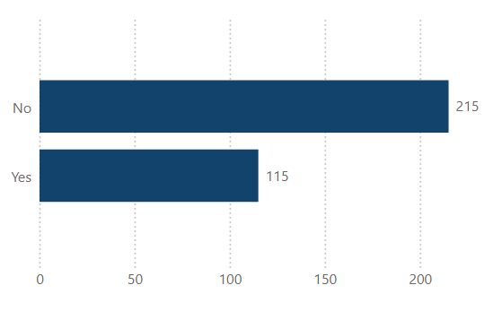

Table of data

 | Number | Percentage
No | 215 | 65%
Yes | 115 | 35%
TOTAL | 330 | 100%

Figure 2 – Number of responses by nation (Q5)
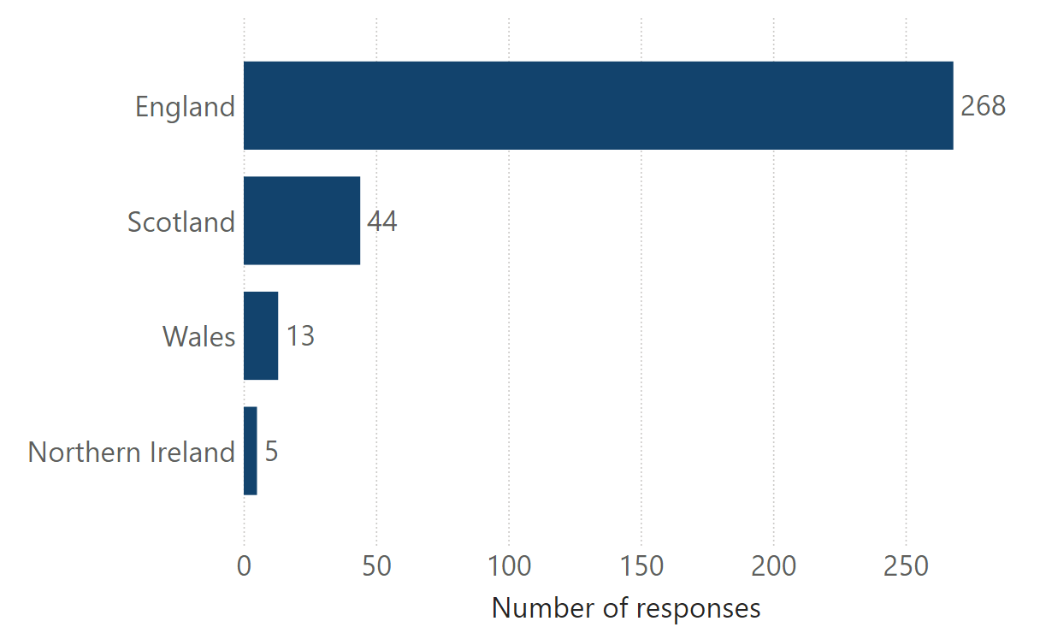
Table of data

 | Number | Percentage
England | 268 | 81%
Scotland | 44 | 13%
Wales | 13 | 4%
Northern Ireland | 5 | 2%
TOTAL | 330 | 100%

Figure 3 – Number of responses in England by region
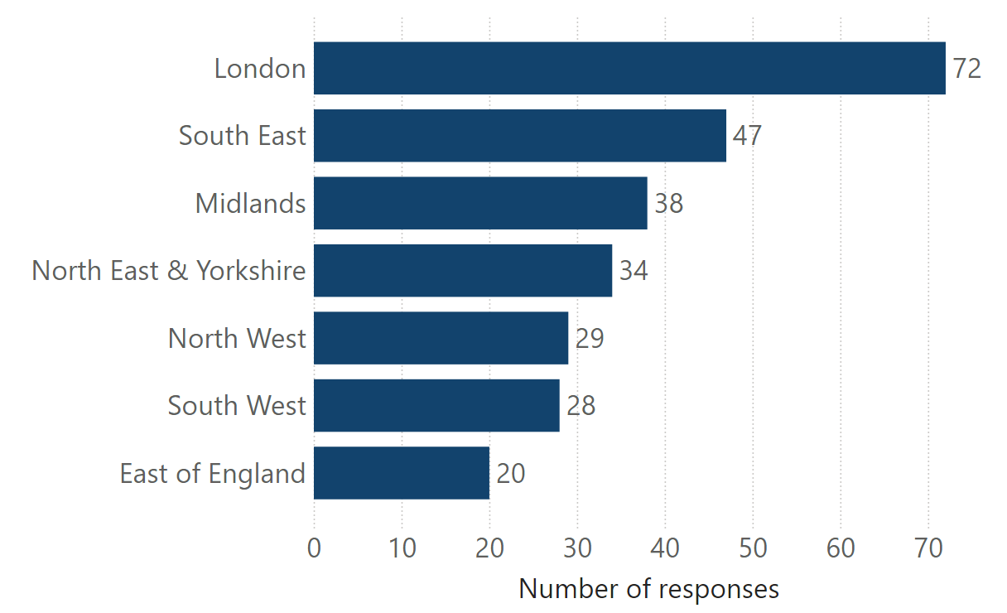
Table of data

 | Number | Percentage
London | 72 | 27%
South East | 47 | 18%
Midlands | 38 | 14%
North East & Yorkshire | 34 | 13%
North West | 29 | 11%
South West | 28 | 10%
East of England | 20 | 7%
TOTAL | 268 | 100%

Figure 4 – Number of responses by category of service
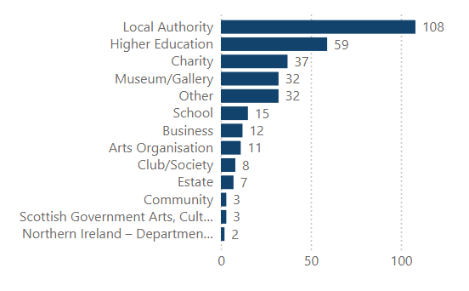
Table of data

 | Number | Percentage
Local authority | 108 | 33%
Higher Education | 59 | 18%
Charity | 37 | 11%
Museum/Gallery | 32 | 10%
Other | 32 | 10%
School | 15 | 5%
Business | 12 | 4%
Arts Organisations | 11 | 3%
Club/Society | 8 | 2%
Estate | 7 | 2%
Community | 3 | <1%
Scottish Government – Arts, Culture, and Heritage Organisation | 3 | <1%
Northern Ireland – Department of Communities | 2 | <1%
DCMS Organisation (England only) | 1 | <1%
TOTAL | 330 | 100%

1.4 Weaknesses and constraints

Sample size

It is difficult to know how many archive services exist in the UK, but there are 2,500 archive collections listed on The National Archives’ Find An Archive directory. Therefore, the 330 responses could represent 10-20% of UK archive services. This is a relatively small sample. However, response rates were relatively good for accredited archive services (61% - 115/189) and local authorities (about 69%, 108/157). Certain types of services (e.g. local authorities) appear more likely to complete the survey than others and this should be taken into account when interpreting the analysis.

Services within larger organisations

Some archive services that are part of larger organisations, such as a museum or a library, indicated that they struggled to answer some questions. For example, their budget may be part of the organisational budget, they deliver joint learning events and exhibitions, or they are unable to identify staffing levels easily for the archives function. One respondent indicated that as a result they did not answer certain questions. Whilst others appear to have answered some questions for their parent organisation, in particular for total staffing and visitor numbers. This results in some exceptionally high values that skew the data. For this reason, we have calculated both averages and medians.

Smaller / volunteer-led services

Some smaller or volunteer-led services fed back that they struggled to complete certain questions, which were not relevant to their service. Others felt the survey did not capture everything they deliver. This was a particular issue for those services that are digital only and do not have an in-person offer.

Year

There was some feedback from respondents that the survey did not make it clear what was meant by “last year”. For example, did it mean calendar year or financial year? Therefore, it is likely that the data covers different years. Some responses will be for the calendar year (2024). Services that use the financial year for data collection, may respond for the period April 2023-March 2024. Some suggested that the survey should be issued after April so they can include their latest data.

Missing values

The accompanying Technical Note outlines the missing values for each variable. However, the following have a high proportion of missing values:

- Q24. How many cubic metres of analogue archive holdings do you have? 118/330 (36%).
- Q28. How many more years can your current ONSITE storage facility accommodate your archive storage needs? 131/330 (40%).
- Q29. How many more years can your current OFFSITE storage facility accommodate your archive storage needs? 270/330 (82%).
- Q32. How many gigabytes (GB) of born-digital archival holdings do you hold? 147/330 (45%).
- Q44. How many analogue items has your archive produced in the last year?
143/330 (43%).
- Q45.1 How many born-digital items were accessed in the last year (GB)? 233/330 (71%).
- Q45.2 How many born-digital items were accessed in the last year (Number)? 186/330 (56%).
- Q53. How many followers/subscribers did your archive have to its social media accounts? 150/330 (45%).
- Q54. What was the total number of unique visitors to your website? 189/330 (57%).

2. Results

All results exclude missing values unless otherwise stated.

2.1 Finance

Figure 5 – What was your annual budget in the last financial year? (Q8)
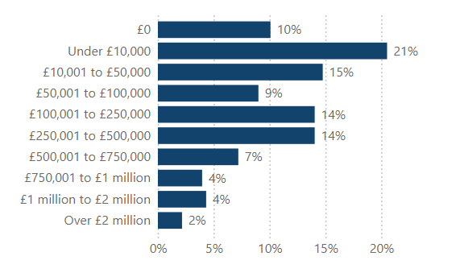
Table of data

 | Number | Percentage
£0 | 28 | 10%
Under £10,000 | 57 | 21%
£10,001 to £50,000 | 41 | 15%
£50,001 to £100,000 | 25 | 9%
£100,001 to £250,000 | 39 | 14%
£250,001 to £500,000 | 39 | 14%
£500,001 to £750,000 | 20 | 7%
£750,000 to £1 million | 11 | 4%
£1 million to £2 million | 12 | 4%
Over £2 million | 6 | 2%
TOTAL | 278 | 100%

Missing values=52 (7 missing and 45 “figures not available”)

Figure 6 – In real terms (adjusting for inflation) has your annual budget changed in the last financial year? (Q9)
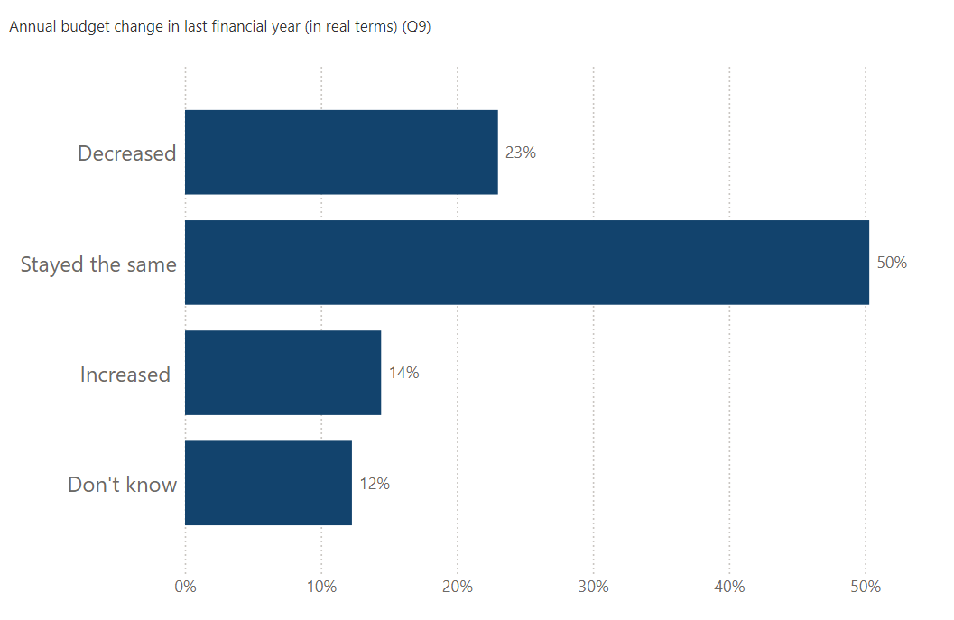
Table of data

 | Number | Percentage
Decreased | 75 | 23%
Stayed the same | 164 | 50%
Increased | 47 | 14%
Don’t know | 40 | 12%
TOTAL | 326 | 100%

Missing values=4

Table 1 – Sources of project funding (revenue) in the last financial year (Q10)

 | Number - Yes | Percentage - Yes
Not applicable | 91 | 28%
Arts Council England | 18 | 6%
Government | 26 | 8%
Local Authority | 96 | 29%
Heritage Fund | 27 | 8%
The National Archives | 23 | 7%
Local Community Trust | 17 | 5%
Other | 113 | 34%

Figure 7 – How much money did your archive receive, in revenue grant income, in the last financial year (Q11)
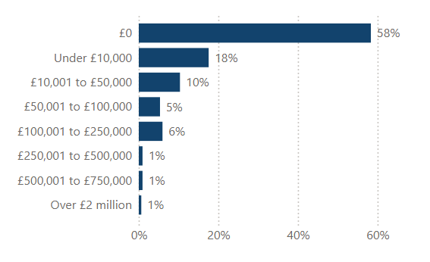
Table of data

 | Number | Percentage
£0 | 186 | 58%
Under £10,000 | 56 | 18%
£10,001 to £50,000 | 33 | 10%
£50,001 to £100,000 | 17 | 5%
£100,001 to £250,000 | 19 | 6%
£250,001 to £500,000 | 3 | <1%
£500,001 to £750,000 | 3 | <1%
£750,000 to £1 million | 0 | 0%
£1 million to £2 million | 0 | 0%
Over £2 million | 2 | <1%
TOTAL | 319 | 100%

Missing values=11

Figure 8 – How much money did your archive receive in capital grant in the last financial year? (Q12)
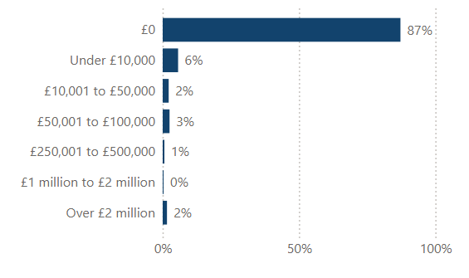
Table of data

 | Number | Percentage
£0 | 278 | 87%
Under £10,000 | 18 | 6%
£10,001 to £50,000 | 7 | 2%
£50,001 to £100,000 | 8 | 3%
£100,001 to £250,000 | 0 | 0%
£250,001 to £500,000 | 2 | <1%
£500,001 to £750,000 | 0 | 0%
£750,000 to £1 million | 0 | 0%
£1 million to £2 million | 1 | <1%
Over £2 million | 5 | 2%
TOTAL | 319 | 100%

Missing values=11

Figure 9 – What was the value of your earned income in the financial year? (Q13)
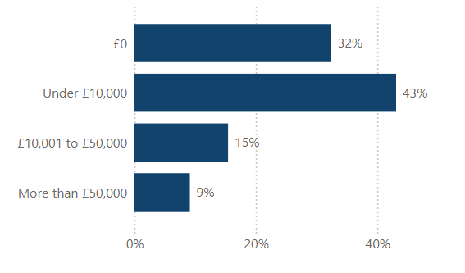
Table of data
 | Number | Percentage
£0 | 103 | 32%
Under £10,000 | 137 | 43%
£10,001 to £50,000 | 49 | 15%
More than £50,000 | 29 | 9%
TOTAL | 318 | 100%

Missing values=12

2.2 Workforce and volunteering

Table 2 – Number of staff (Q14-Q20)

 | Average per service (FTE) | Median per service (FTE) | Number of missing values
All paid staff | 8.15 | 2.5 | 15
Qualified archivist | 2.18 | 1 | 13
Non-qualified archivists/assistants | 2.43 | 1 | 18
Qualified conservation staff | 0.41 | 0 | 24
Non-qualified conservation staff | 0.21 | 0 | 22
Education and learning staff | 0.37 | 0 | 27
Records management staff | 0.39 | 0 | 29

Figure 10 – What is the total full-time equivalent count of paid staff employed at your archive? (Q14 Categorical)
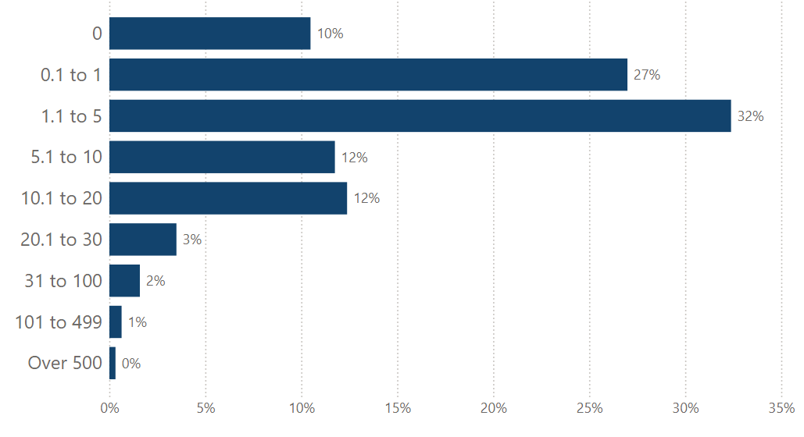
Table of data

 | Number | Percentage
0 | 33 | 10%
0.1 to 1 | 85 | 27%
1.1 to 5 | 102 | 32%
5.1 to 10 | 37 | 12%
10.1 to 20 | 39 | 12%
20.1 to 30 | 11 | 3%
31 to 100 | 5 | 2%
101 to 499 | 2 | 1%
Over 500 | 1 | <1%
TOTAL | 315 | 100%

Missing values=15

Table 3 – Volunteer numbers and hours (Q21-Q23)

 | Average per service | Median per service | Number of missing values
Number of volunteers | 14.74 | 4 | 17
Volunteer hours (onsite) | 1,182 | 250 | 46
Volunteer hours (online) | 134 | 0 | 68
Volunteer hours (all) | 1,301 | 326 | 45

Note – the analysis includes those services that do not host volunteers and entered 0. 79% of services hosted volunteers.

2.3 Collections management

Table 4 – Holdings and storage (Q24, Q25, Q28, Q32)

 | Average per service | Median per service | Number of missing values
Analogue archive holdings (cubic metres) | 615 | 190 | 118
Percentage stored to BS4971 | 68 | 90 | 53
Onsite accrual space (years) | 9.11 | 5 | 131
Born-digital archival holdings (GB) | 6,232 | 155 | 147

Figure 11 – Do you use commercial storage for archival holdings? (Q30)

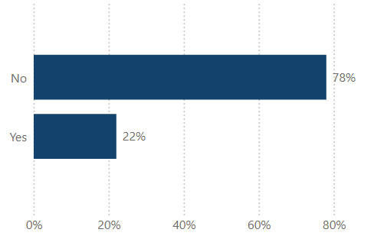

Table of data

 | Number | Percentage
No | 255 | 78%
Yes | 72 | 22%
TOTAL | 327 | 100%

Missing values=3

Table 5 – What is the main collection management system (CMS) you currently use? (Q30)
 | Number - Yes | Percentage – Yes
None | 57 | 17%
AdLib | 11 | 3%
ArchivesSpace | 9 | 3%
AtoM | 21 | 6%
Axiell Collections | 20 | 6%
Axiell Emu | 7 | 2%
Bespoke/in-house | 22 | 7%
CALM | 107 | 32%
Collections Index (System Simulation) | 6 | 2%
CollectionsBase (Orangeleaf Systems) | 7 | 2%
ContentDM (OCLC) | 2 | <1%
Dryad (Max Communications) | 1 | <1%
eHive (Vernon Systems) | 2 | <1%
Epexio (Metadatis) | 26 | 8%
Koha | 1 | <1%
M2A (Minisis) | 1 | <1%
Mimsy | 7 | 2%
Modes | 10 | 3%
Qi | 2 | <1%
SDS Archive Manager | 2 | <1%
Soutron Archive | 5 | 2%
Spydus (Civica) | 6 | 2%
TMS Media Studio (Gallery Systems) | 1 | <1%
VernonCMS | 3 | <1%
Other | 43 | 13%

Table 6 – What is the main digital preservation management system (DPS) you currently use? (Q34)
 | Number - Yes | Percentage – Yes
None | 166 | 50%
Archivematica | 11 | 3%
Arkivum Perpetua | 2 | <1%
EPrints | 2 | <1%
Fedora | 1 | <1%
In-house workflows connecting tools into a digital preservation architecture | 39 | 12%
Libsafe (Libnova) | 2 | <1%
Preservica | 72 | 22%
Other | 33 | 10%

Table 7 – Does your service use any of the following tools or standards to guide your approach to digital preservation? (Q33)
 | Number - Yes | Percentage – Yes
None in use | 151 | 46%
Core Trust Seal | 5 | 2%
DiAGRAM | 5 | 2%
Digital Preservation Coalition Rapid Assessment Model | 98 | 30%
ISO 16363 | 16 | 5%
NDSA Levels of Digital Preservation | 73 | 22%
OAIS Reference Model | 73 | 22%
Other | 15 | 5%

Figure 12 – What kind of conservation do you have access to (Q26)?
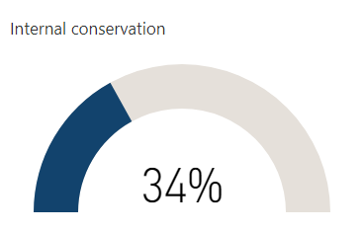
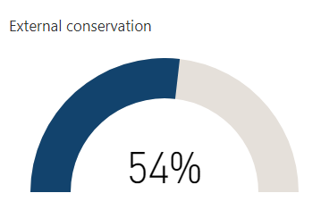

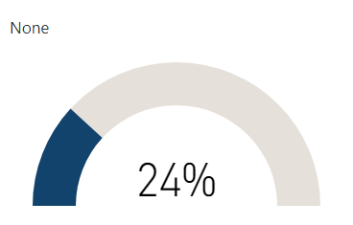
Table of data

 | Number - Yes | Percentage - Yes
Internal | 112 | 34%
External | 177 | 54%
None | 78 | 24%

Missing values=4

Table 8 – Catalogues: percentage catalogued and online
 | Average per service | Median per service | Number of missing values
Percentage of archive collection fully catalogued | 55% | 60% | 37
Percentage of archive collection with full catalogue online | 41% | 40% | 42
Percentage of archive collection completely unlisted | 21% | 12% | 55

2.4 Access and engagement

Figure 13 – Is your archive open to the general public? (in-person) (Q38)
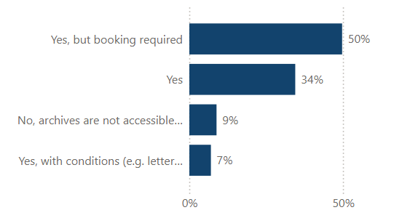
Table of data

 | Number | Percentage
No | 29 | 9%
Yes | 113 | 34%
Yes but booking required | 163 | 50%
Yes with conditions e.g. letter of introduction | 23 | 7%
TOTAL | 328 | 100%

Missing values=2

Figure 14 – Does your archive service provide free public Wi-Fi? (Q46)
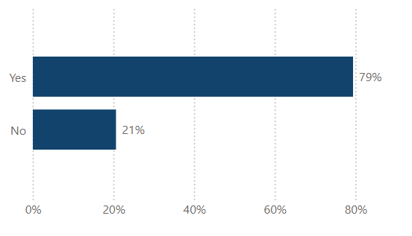
Table of data

 | Number | Percentage
No | 67 | 21%
Yes | 258 | 79%
TOTAL | 325 | 100%

Missing values=5

Figure 15 – Does your archive service have access to a library collection that supports research into your archival holdings? (Q27)

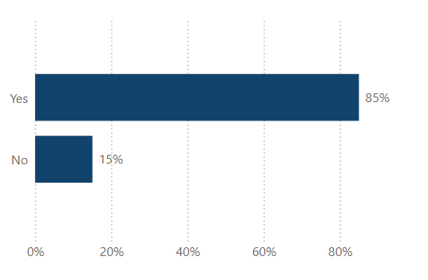
Table of data

 | Number | Percentage
No | 49 | 15%
Yes | 277 | 85%
TOTAL | 326 | 100%

Missing values=4

Figure 16 – Does your archive service collect demographic data about your audiences? (Q51)
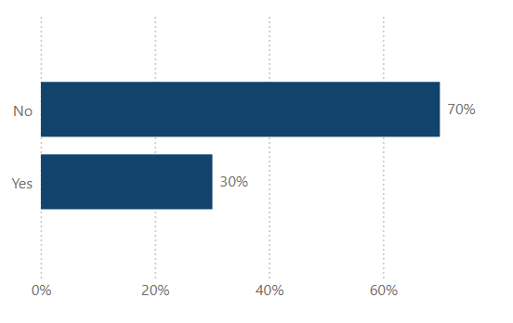
Table of data

 | Number | Percentage
No | 228 | 70%
Yes | 98 | 30%
TOTAL | 326 | 100%

Missing values=4

Table 9 – In-person opening hours and reader spaces (Q40-Q42)

 | Average per service | Median per service | Number of missing values
Hours open per week | 25.33 | 24 | 45
Weeks open per year | 47.13 | 50 | 38
Hours open per year | 1,330 | 1,194 | 50
Number of onsite readers service can accommodate at one time | 12.96 | 6 | 22

Note – only those services that are open to the public included in the analysis.

Table 10 – Visits, enquiries, and productions in the past year (Q39, Q43-Q45)

 | Average per service | Median per service | Number of missing values
In-person visits (those services open to the public in-person only) | 5,092 | 360 | 46
Enquiries | 1,565 | 467 | 59
Analogue items produced | 5,185 | 2,125 | 143
Born-digital items accessed (GB) | 4.60 | 0 | 233
Born-digital items accessed (number) | 34,111 | 0 | 186

Figure 17 - How many onsite and offsite learning and outreach events combined did your archive service hold in the last year? (Q47)
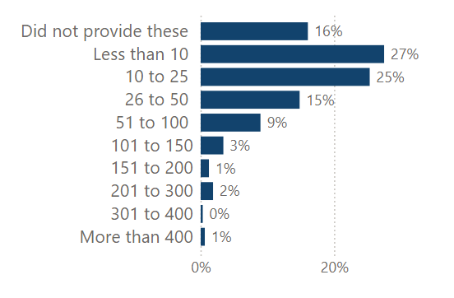
Table of data

 | Number | Percentage
Did not provide these | 52 | 16%
Less than 10 | 89 | 27%
10 to 25 | 82 | 25%
26 to 50 | 48 | 15%
51 to 100 | 29 | 9%
101 to 150 | 11 | 3%
151 to 200 | 4 | 1%
201 to 300 | 6 | 2%
301 to 400 | 1 | <1%
More than 400 | 2 | <1%
TOTAL | 324 | 100%

Missing values=6

Figure 18 - How many participants did your archive engage in learning and outreach sessions online? (Q48)
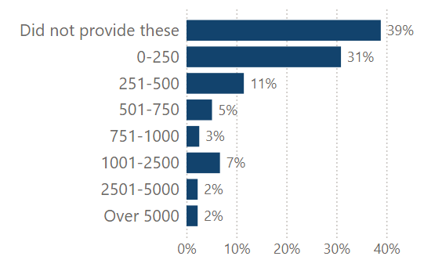
Table of data

 | Number | Percentage
Did not provide these | 122 | 39%
0-250 | 97 | 31%
251-500 | 36 | 11%
501-750 | 16 | 5%
751-1000 | 8 | 3%
1001-2500 | 21 | 7%
2501-5000 | 7 | 2%
Over 5000 | 7 | 2%
TOTAL | 314 | 100%

Missing values=16

Figure 19 - How many visitors attended your exhibitions on-site and off-site in the last year? (Q49)
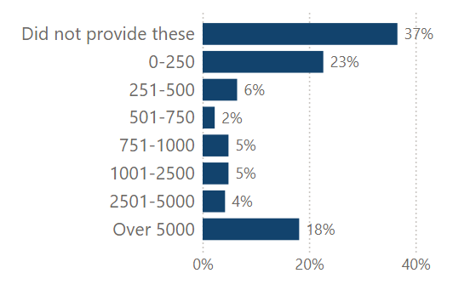
Table of data

 | Number | Percentage
Did not provide these | 113 | 37%
0-250 | 70 | 23%
251-500 | 20 | 6%
501-750 | 7 | 2%
751-1000 | 15 | 5%
1001-2500 | 15 | 5%
2501-5000 | 13 | 4%
Over 5000 | 56 | 18%
TOTAL | 309 | 100%

Missing values=21

Figure 20 - How many visitors attended your exhibitions online in the last year? (Q50)
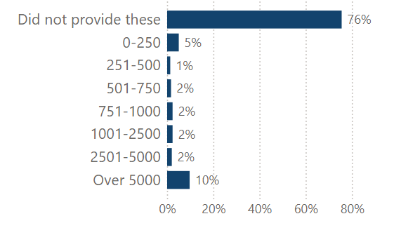
Table of data

 | Number | Percentage
Did not provide these | 225 | 76%
0-250 | 15 | 5%
251-500 | 4 | 1%
501-750 | 5 | 2%
751-1000 | 7 | 2%
1001-2500 | 7 | 2%
2501-5000 | 6 | 2%
Over 5000 | 29 | 10%
TOTAL | 298 | 100%

Missing values=32

Table 11 – Does your archive use any of the following social media platforms (Q52)?
 | Number - Yes | Percentage - Yes
Twitter/X | 126 | 38%
Facebook | 148 | 45%
Instagram | 123 | 37%
YouTube | 65 | 20%
Threads | 9 | 3%
Blog | 62 | 19%
Pinterest | 2 | <1%
TikTok | 6 | 2%
Flickr | 24 | 7%
Bluesky | 24 | 7%
Mastodon | 0 | 0%
None in use | 23 | 7%
Don’t know | 1 | <1%
No but contribute to parent organisation' accounts | 123 | 37%

Figure 21 - Was the service able to provide how many followers/subscribers they have to their social media accounts? (Q53)
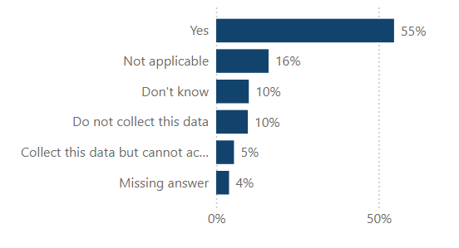
Table of data

 | Number | Percentage
Yes | 180 | 55%
Not applicable | 53 | 16%
Don’t know | 33 | 10%
Do not collect data | 32 | 10%
Collect this data but cannot access | 18 | 5%
Missing values | 14 | 4%
TOTAL | 330 | 100%

Figure 22 - How many followers/subscribers did your archive have to its social media accounts? (Q53)
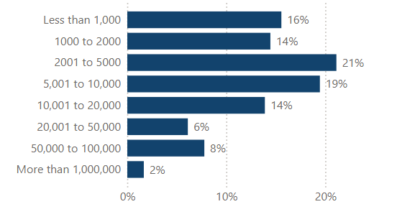
Table of data

 | Number | Percentage
Less than 1000 | 28 | 16%
1000 to 2000 | 26 | 14%
2001 to 5000 | 38 | 21%
5001 to 10,000 | 35 | 19%
10,001 to 20,000 | 25 | 14%
20,001 to 50,000 | 11 | 6%
50,000 to 100,000 | 14 | 8%
More than 1,000,000* | 3 | 2%
TOTAL | 180 | 100%

*This was included in the survey but should probably read 100,000

Missing values=150 (includes not applicable/don't know/do not collect/unable to access)

Figure 23 - Was the service able to provide the total number of unique visitors to their website? (Q54)
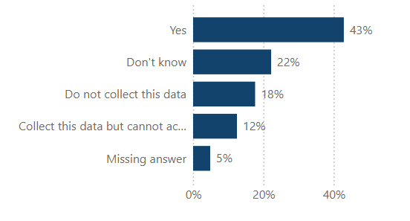
Table of data

 | Number | Percentage
Yes | 141 | 43%
Don’t know | 73 | 22%
Do not collect data | 58 | 18%
Collect this data but cannot access | 41 | 12%
Missing data | 17 | 5%
TOTAL | 330 | 100%

Figure 24 - What was the total number of unique visitors to your website? (Q54)
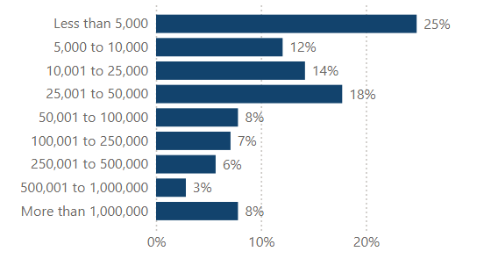
Table of data

 | Number | Percentage
Less than 5,000 | 35 | 25%
5,000 to 10,000 | 17 | 12%
10,001 to 25,000 | 20 | 14%
25,001 to 50,000 | 25 | 18%
50,001 to 100,000 | 11 | 8%
100,001 to 250,000 | 10 | 7%
250,001 to 500,000 | 8 | 6%
500,001 to 1,000,000 | 4 | 3%
More than 1,000,000 | 11 | 8%
TOTAL | 141 | 100%

Missing values=189 (includes not applicable/don't know/do not collect/unable to access)

3. Advanced analysis

3.1 Correlations

Correlation analysis is a statistical method that determines the strength and direction of the relationship between two variables. We were asked to undertake correlation analysis to understand whether there is a relationship between:

        - Budget and use & engagement
        - Opening hours and in-person visits
        - The proportion of collections catalogued and use & engagement
        - Resourcing levels and the proportion of collections catalogued
        - Different forms of engagement and use of archives

Where we had two continuous variables, they failed the assumptions of Pearson's correlation for normality and outliers. Therefore, we used Spearman's rank-order correlation, which calculates a coefficient (r_{s} or ρ), a measure of the strength and direction of the relationship between two continuous or ordinal variables. We also used Spearman's rank-order correlation where there was at least one ordinal variable. Pairwise deletion was applied.

The results are shown in Tables 12-16 below. In summary, the only relationships of large strength were between annual budget and the number of learning & outreach events and annual budget and number of unique visitors to website. There were also relationships of medium strength between various forms of engagement (number of learning & outreach events, exhibition visitors, and website visitors) and the number of analogue items produced. It is important to note that correlation does not imply causation, as other factors can influence the relationship between variables.

Table 12 - Relationships between budget and use & engagement

Variable 1 | Variable 2 | Strength of relationship | Statistically significant
Annual budget (Q8) | In-person visits (Q39) | Small (positive)  r_{s}=0.114 | No  p=0.080
Annual budget (Q8) | Number of learning and outreach events (Q47) | Large (positive)  r_{s}=0.561 | Yes  p < 0.001
Annual budget (Q8) | Number of unique visitors to website (Q54) | Large (positive)  r_{s}=0.600 | Yes  p < 0.001

Table 13 - Relationship between opening hours and in-person visits

Variable 1 | Variable 2 | Strength of relationship | Statistically significant
In-person visits (Q39) | Opening hours per year (Q41.2) | Small (positive)  r_{s}=0.054 | No  p=0.405

Table 14 - Relationship between the proportion of collections catalogued and use & engagement

Variable 1 | Variable 2 | Strength of relationship | Statistically significant
Percentage of archive collection fully catalogued (Q36) | In-person visits (Q39) | Small (positive)  r_{s}=0.023 | No  p=0.719
Percentage of archive collection fully catalogued (Q36) | Number of analogue items produced (Q44) | Small (positive)  r_{s}=0.120 | No  p=0.112
Percentage of archive collection fully catalogued (Q36) | Number of learning and outreach events (Q47) | Small (positive)  r_{s}=0.102 | No  p=0.083
Percentage of archive collection fully catalogued (Q36) | Number of unique visitors to website (Q54) | Small (positive)  r_{s}=0.030 | No  p=0.737

Table 15 - Relationship between resourcing levels and the proportion of collections catalogued

Variable 1 | Variable 2 | Strength of relationship | Statistically significant
Annual budget (Q8) | Percentage of archive collection fully catalogued (Q36) | Small (positive)  r_{s}=0.240 | Yes  p < 0.001
Total staff (Q14) | Percentage of archive collection fully catalogued (Q36) | Small (positive)  r_{s}=0.47 | No  p=0.432

Table 16 - Relationship between different forms of engagement and use of archives

Variable 1 | Variable 2 | Strength of relationship | Statistically significant
Number of learning and outreach events (Q47) | Number of analogue items produced (Q44) | Medium (positive)  r_{s}=0.360 | Yes  p < 0.001
Number of unique visitors to website (Q54) | Number of analogue items produced (Q44) | Medium (positive)  r_{s}=0.350 | Yes  p < 0.001
Visitors to exhibitions (Q49) | Number of analogue items produced (Q44) | Medium (positive)  r_{s}=0.352 | Yes  p < 0.001

3.2 Group differences

Between-groups statistical tests are used to determine whether there are differences between two or more groups of related and/or unrelated (independent) cases on a dependent variable. We were asked to undertake between group tests to understand if there is a difference in:

- Resourcing levels between accredited and non-accredited archive services.
- Resourcing levels between services using digital preservation standards/tools and those that are not.

We used the Mann-Whitney U test, a rank-based nonparametric test that can be used to determine if there are differences between two groups on an ordinal dependent variable.

A Mann-Whitney U test was run to determine if there were differences in the annual budget between accredited and non accredited archive services. Distributions of the annual budget for the two groups were not similar, as assessed by visual inspection. The annual budget for accredited services (mean rank = 200.69) was statistically significantly higher than for non accredited services (mean rank = 102.36). U = 2658, z = -9.984, p < 0.01.
A Mann-Whitney U test was run to determine if there were differences in the annual budget between those services that use digital preservation tools/standards and those that do not. Distributions of the annual budget for the two groups were not similar, as assessed by visual inspection. The annual budget for those services that do use digital preservation standards/tools (mean rank = 172.24) was statistically significantly higher than for those that do not (mean rank = 98.84), U = 4506, z = -7.642, p < 0.01.

