Government  Document  Request Form |  |  | 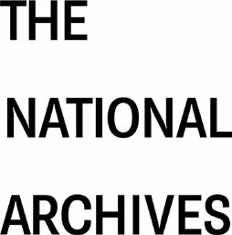
Name: |  | Date:
Department: |  | TNA Ticket:
Address:
Email:
Delivery Method:

View Onsite at TNA (please give dates & attendees below) ☐

Copies (cost recovery charge applies) ☐

Original Documents (pending authorisation) ☐
Additional Comments/Instructions:
Please email completed forms to government@nationalarchives.gov.uk

Telephone: +44(0)208 392 5260

Government & Remote Services
The National Archives
Kew, Richmond TW9 4DU
Please list documents required giving full TNA references
e.g. ‘FO 371/110438’ Department=FO, Series=371, Piece=110438
You can specify a range of piece numbers e.g. ‘1-10’
Search/check references on our Discovery catalogue

Department | Series | Piece/Item/Range | Comments/Instructions

Additional rows may be added as required

