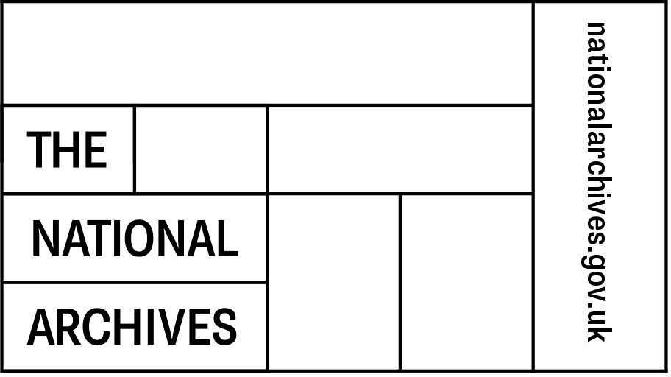

Authorised Requestors Form
Department Name:
Department Address:
Date:
TNA Ticket Number:
This form is for Departmental Record Officers (DROs), or their nominated deputy, to assign authority for access to records that originated in their department and which are held by The National Archives (TNA). By completing and submitting this form you accept the following conditions of use:

- All authorised requestors agree to keep requisitioned records secure and agree not to move the records to a third party unless previously agreed with The National Archives.

- The authorised requestor will be held responsible for the records and any copies made while in use or out of the custody of TNA. If a record is misplaced it should be reported to Government and Remote Services (GRS) at The National Archives immediately.

- If records are misplaced whilst requisitioned then TNA will carry out an audit of the requisitioning department’s record storage arrangements and tracking procedures. The DRO will then be requested to prepare a report for TNA outlining the steps that they have taken to locate the record(s) and mitigate the risk of a similar incident happening in the future. In certain instances requisition services will be suspended whilst the audit is carried out and until revised procedures are put in place by the requisitioning organisation.

- GRS will hold only one Authorised Requestor form for each departmental branch that has been given a TNA ticket number to requisition records. Therefore whilst additional Authorised Requestors can be added at any time, the Authorised Requestor form will need to include all those in the branch that continue to need to requisition records. Once authorised by the appropriate DRO (or their nominated deputy), and submitted to GRS, the most recent Authorised Requestors form will replace, and invalidate, any previous form held by TNA for that branch.

- Records should be returned to TNA within agreed timescales, up to a maximum of six months from their initial requisition. In exceptional circumstances records may be held for longer if necessary, by arrangement with TNA.

- This form must contain the wet signature of the DRO (or nominated deputy) for it to be accepted by The National Archives. Once completed and signed please send a scanned copy of this form to: government@nationalarchives.gov.uk, or a hard copy by post to: Government and Remote Services, The National Archives, Kew, Richmond, Surrey, TW9 4DU.

- The DRO and Authorised Requestors named on this form are enabled to place orders for dispatch of original records (subject to authorisation), for onsite viewing of records at TNA, or for copies to be made and provided (cost recovery charge applies).

I approve this document in my role as Departmental Records Officer, or as their nominated deputy, as the current Authorised Requestor form lodged with The National
Archives for my department.
DRO/Deputy Name:
DRO/Deputy
Signature:
Email:
Telephone Number:
The following members of staff at this department are hereby authorised to requisition records that originate from this department and which are held at The National Archives:
Authorised Requestor
Full Name:
Job Title:
Email:
Phone Number:
Authorised Requestor
Full Name:
Job Title:
Email:
Phone Number:
Authorised Requestor
Full Name:
Job Title:
Email:
Phone Number:
Authorised Requestor
Full Name:
Job Title:
Email:
Phone Number:
Authorised Requestor
Full Name:
Job Title:
Email:
Phone Number:

Authorised Requestor
Full Name:
Job Title:
Email:
Phone Number:
Authorised Requestor
Full Name:
Job Title:
Email:
Phone Number:
Authorised Requestor
Full Name:
Job Title:
Email:
Phone Number:
Authorised Requestor
Full Name:
Job Title:
Email:
Phone Number:
Authorised Requestor
Full Name:
Job Title:
Email:
Phone Number:
Authorised Requestor
Full Name:
Job Title:
Email:
Phone Number:

