This resource will help you to,
- Navigate existing sources of public data that will tell you more about audiences in the UK.
- Be aware of existing research within Archives that you may wish to join.
- Think about what systems you need to set up in your organisation to collect data about your audiences.

- Existing sources of public data

The Office for National Statistics website
www.ons.gov.uk
What is it?
- The Office for National Statistics (ONS) produces independent information to improve understanding of the UK's economy and society
- The website hosts a huge range of resources and data on a wide range of topics, including:
  - the economy
  - social and welfare
  - tourism
  - crime and justice
  - commerce
  - population figures and trends
This data is available in a number of formats:
  - Stories (press releases)
  - Articles (articles from reports and journals)
  - Data (tables of figures)
  - Products (books for purchase)
  - Sources (external links)
  - Neighbourhood Statistics (wide range of datasets which can be customised using an online tool)

Pros and cons
- Lots of data from a variety of sources
- Data generally very robust
- Uses standard government measures, so the data is widely comparable with other sources
- Versatile – can give you overviews of particular subjects, new research, or your own customised tables and charts
- Takes a bit of time to get used to using Neighbourhood Statistics
- Not much culture-specific content; more useful for building up a picture of an area according to other measures (for instance education, access to services etc)
Where can I find the data?
- Browse through themes from the homepage (www.ons.gov.uk)
- Search for reports from the homepage (www.ons.gov.uk)
- Click “Neighbourhood” on the homepage (or go to http://neighbourhood.statistics.gov.uk/dissemination/) to be taken to Neighbourhood Statistics, where you can create customised tables and charts
Using the ONS Neighbourhood Statistics tool
Neighbourhood Statistics enables you to make your own charts and tables based on the wide variety of data ONS hold. You can look at your data by geographical area, so you can isolate particular areas of interest, or identify which areas have particular characteristics. Follow the walk-through to get to grips with the basics, and spend a bit of time seeing how it might be able to help you.
There are two ways to get data from Neighbourhood Statistics. The first method is the quickest way to get data out for a preset area – perhaps a particular borough, or a ward within a borough – and compare it to other preset areas within the region:
- Go to http://neighbourhood.statistics.gov.uk/dissemination. If you want to find out information about a particular area, enter a postcode, or the name of the borough or ward in which you’re interested, in the box, and choose the type of area you want statistics for :
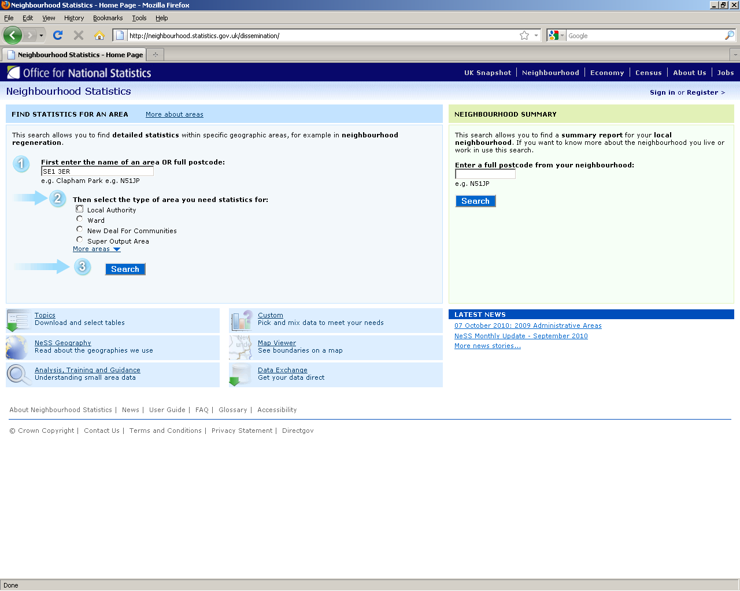
In the example above, choosing ‘Local Authority’ will give you data for Southwark (the borough SE1 3ER is within), and choosing ‘Ward’ would give you data for Grange, which is the ward SE1 3ER is in. This also decides what the data you get is compared to – if you get data for a Local Authority it will be compared with all the other LAs in the region (so in this example Southwark will be compared with all the other London boroughs), and if you get data for a Ward it will be compared with all the other wards within that local authority. All will become clear once we see the maps…
- After choosing the area you’re interested in, all available data for that area will be shown. Click through to the topic you’re interested in…
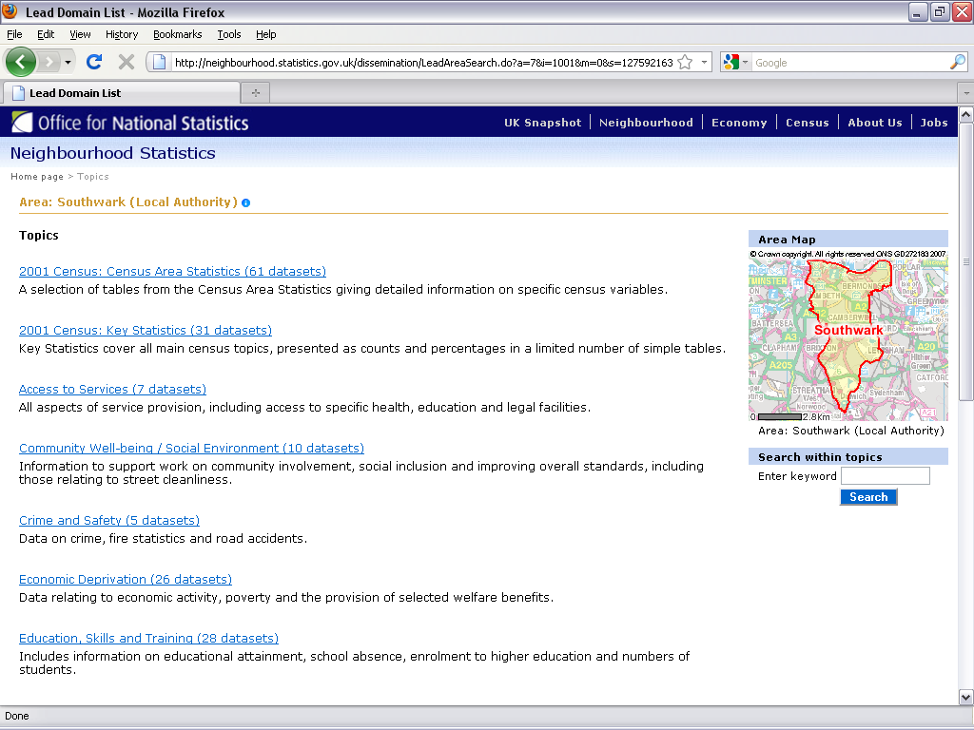

- Your data will look something like this
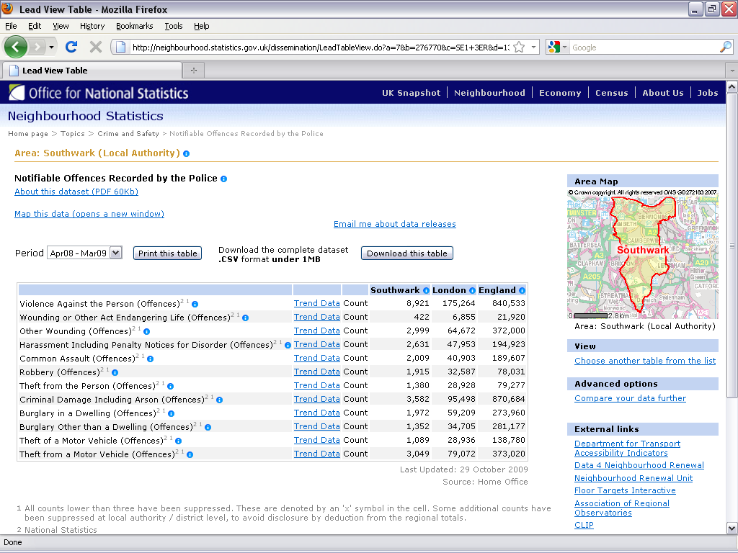
Form this screen, you can:
  - Find out more about the data (where it came from etc) by clicking About this dataset
  - Depending on the data, view it over a different time period by clicking on the Period drop-down
  - Save the data to your computer by clicking Download the table
  - Show the data on a map by clicking Map this data
- If you click Map this data, you’ll see something like this:
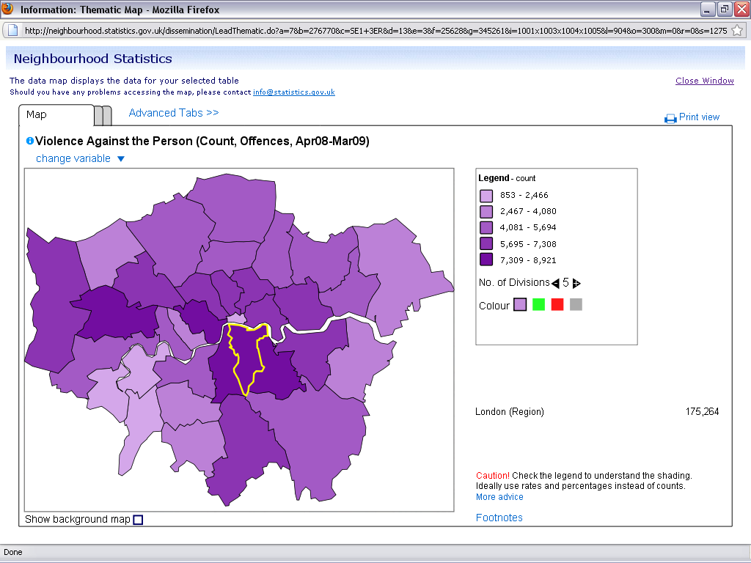
As we previously chose to view data for a Local Authority, we see Southwark (highlighted in yellow) compared to the other boroughs in the region. Each is shaded according to its value on the chosen variable (which in the case above is counts of violence against the person offences by borough between April 2008 and March 2009).
To see another statistic from the previous table across the boroughs, click Change variable and pick from the list.
- Click Advanced tabs to show options for making the map look different. You can change:
  - The colour of the map
  - The number of different groupings on the map
  - Turning on or off a background map to help you understand where the different areas are, in the real world
  - View a graph which shows the same data, but ranked (so the borough with the highest count is at one end of the chart, and that with the smallest count is at the other)
These options can help make the map easier to understand.
- To save the map, either do a screen grab (using the Print Screen button on your keyboard), or, if you have the necessary software, print it as a pdf.

The second method allows you to be more precise about the areas you’re interested in, and show data for multiple areas and multiple topics at once. This can be a much more efficient way of working if you want to pull data for multiple topics and/or multiple areas.
- From the Neighbourhood Statistics page (http://neighbourhood.statistics.gov.uk/dissemination), click Custom - Pick and mix data to meet your needs
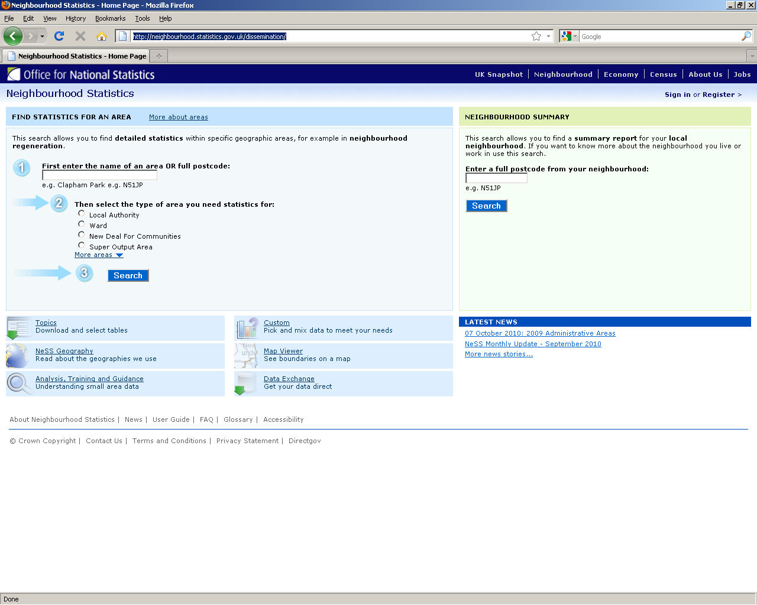
- First, choose whether you want to start building your data by looking at a particular area, or start by defining some topics. We’ll start with topics:
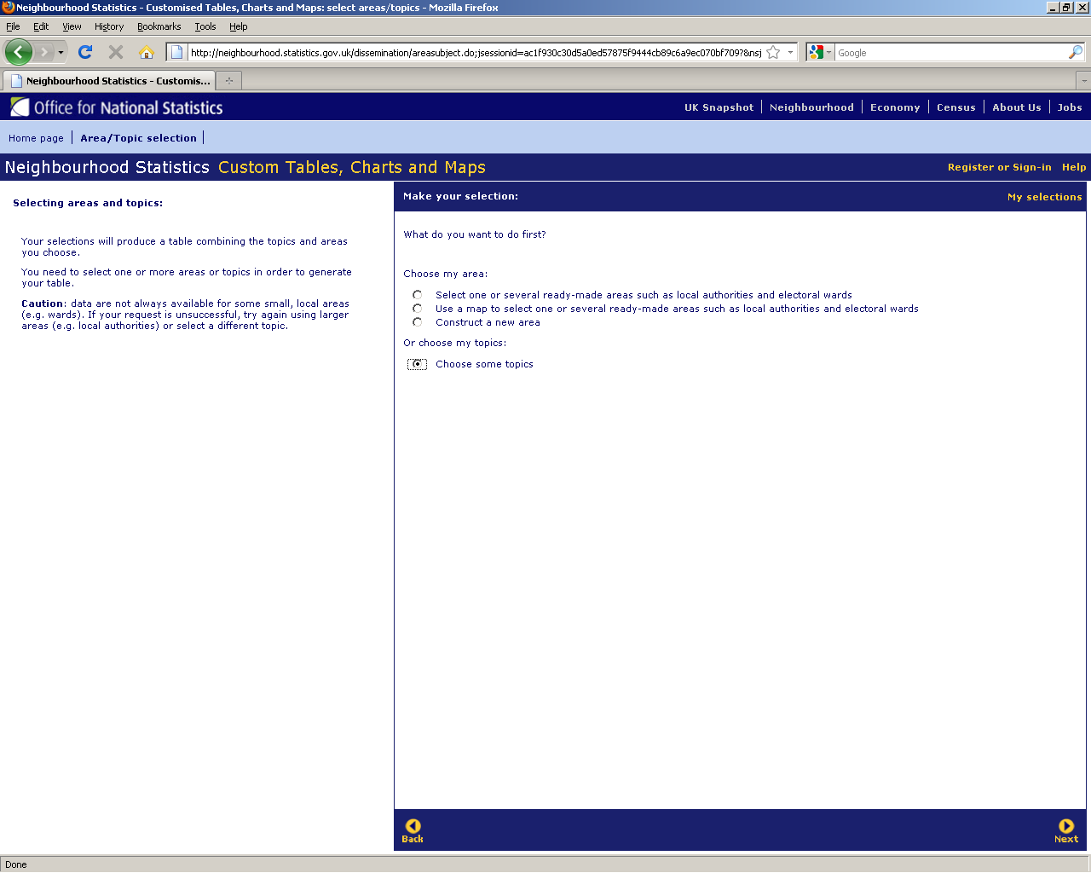
Click Next to move to the next step.
- Click through the areas on the left to find the topics you’re interested in:
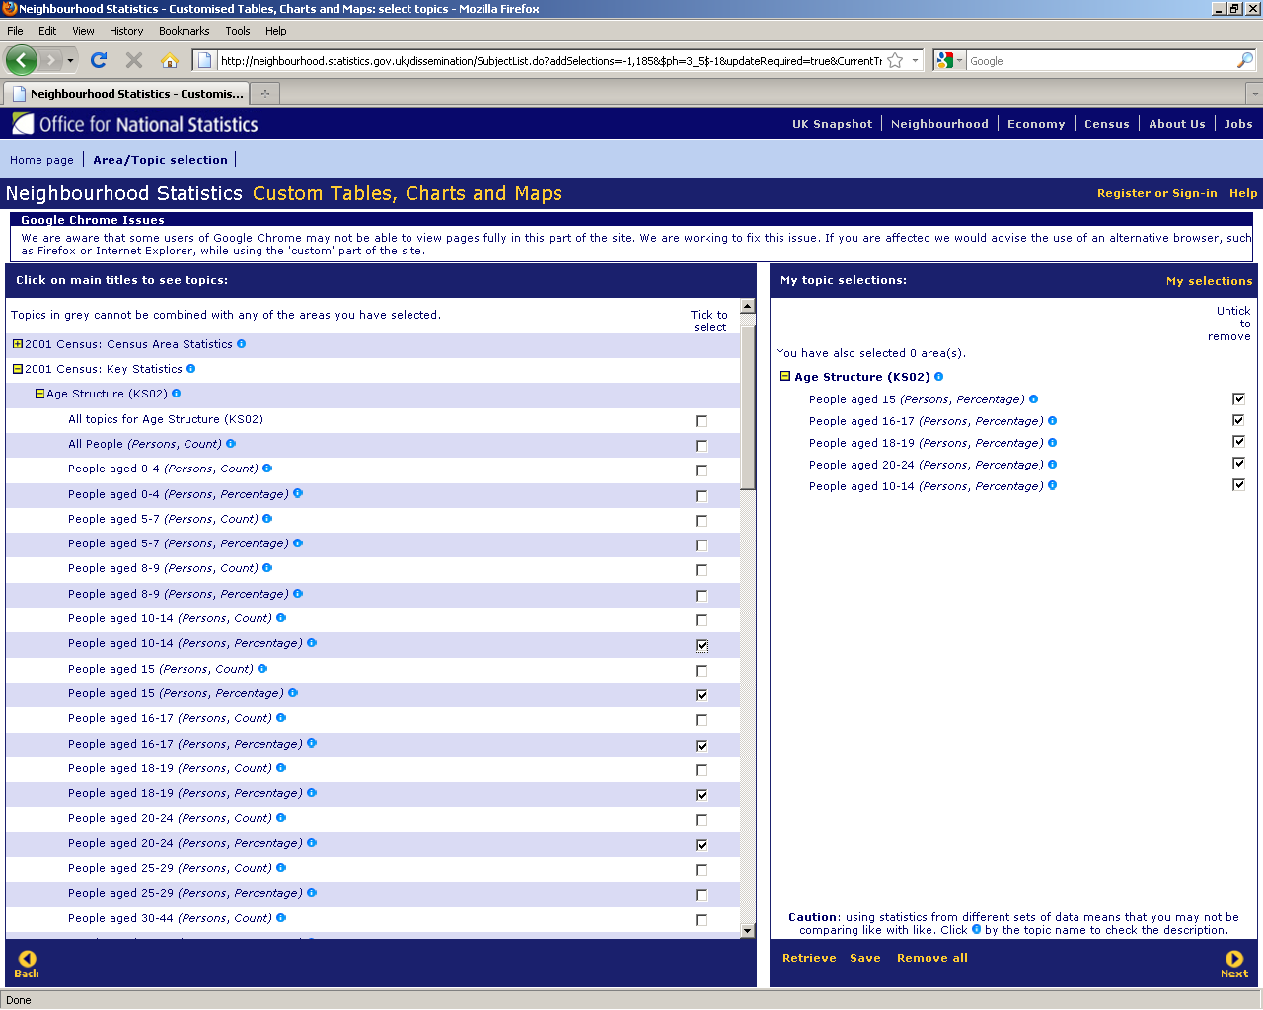
In this example, I’ve decided I want to know about what percentage of those within an area are aged 10-24. Click Next to define the area these figures will be given for...
- You can either choose to use ready-made areas (for example local authorities) by picking them form a list or picking them from a map, or creating a custom area. We’ll go for ready-made areas, and get the data we previously chose for the five Olympic Host Boroughs – click next to continue...
- On the next screen you need to choose which building blocks your area will be made of. The default option, NeSS Geography Hierarchy is not very useful for most purposes. If you’re interested in looking at data for boroughs, chose 2009 Administrative Hierarchy:
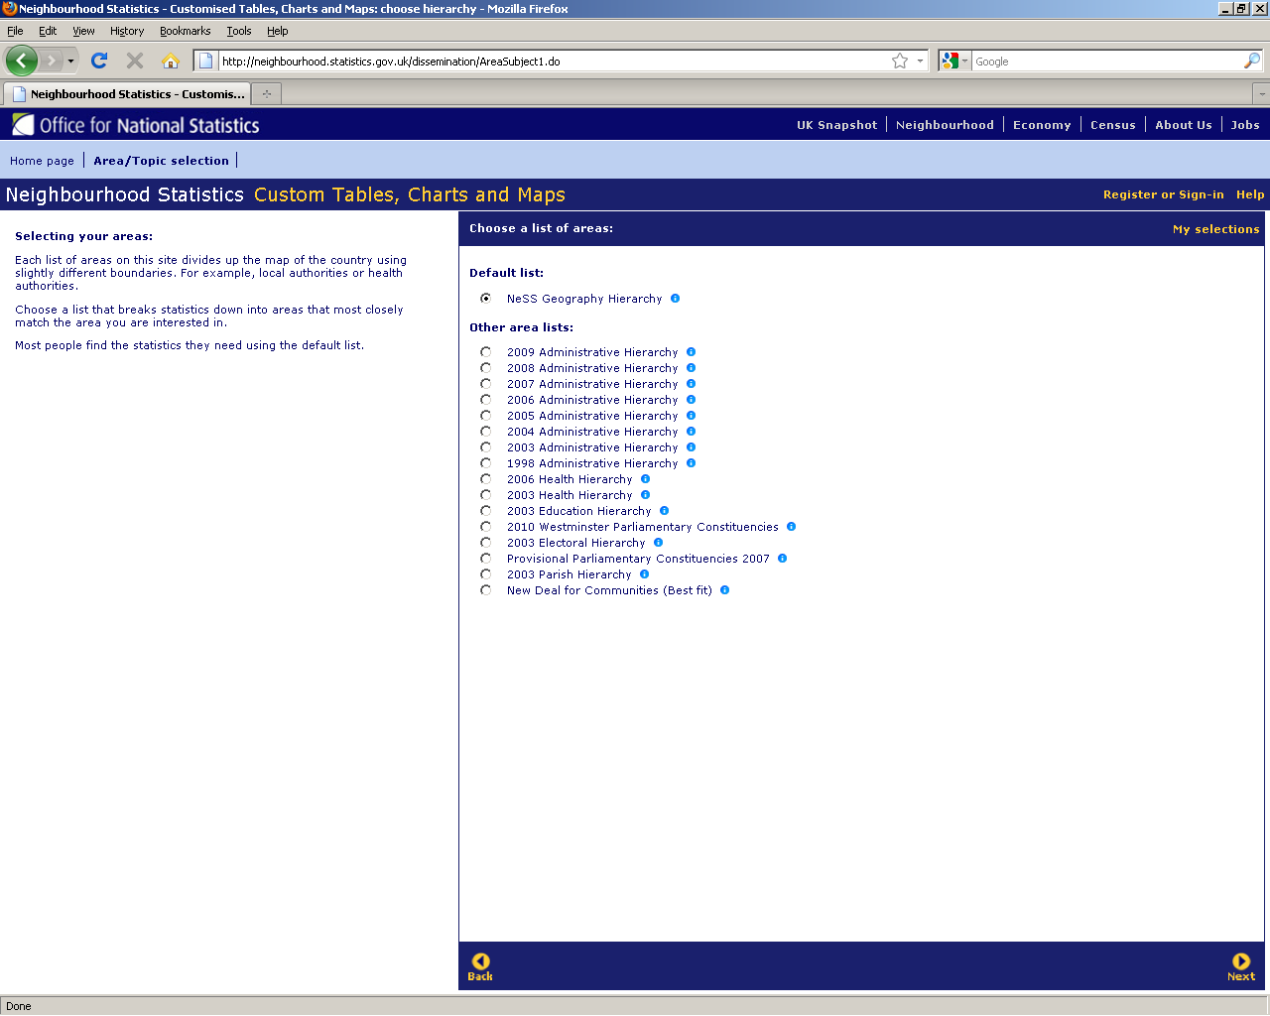
- In the same way as you picked your topics, use the list on the left to find the area(s) you’re interested in:
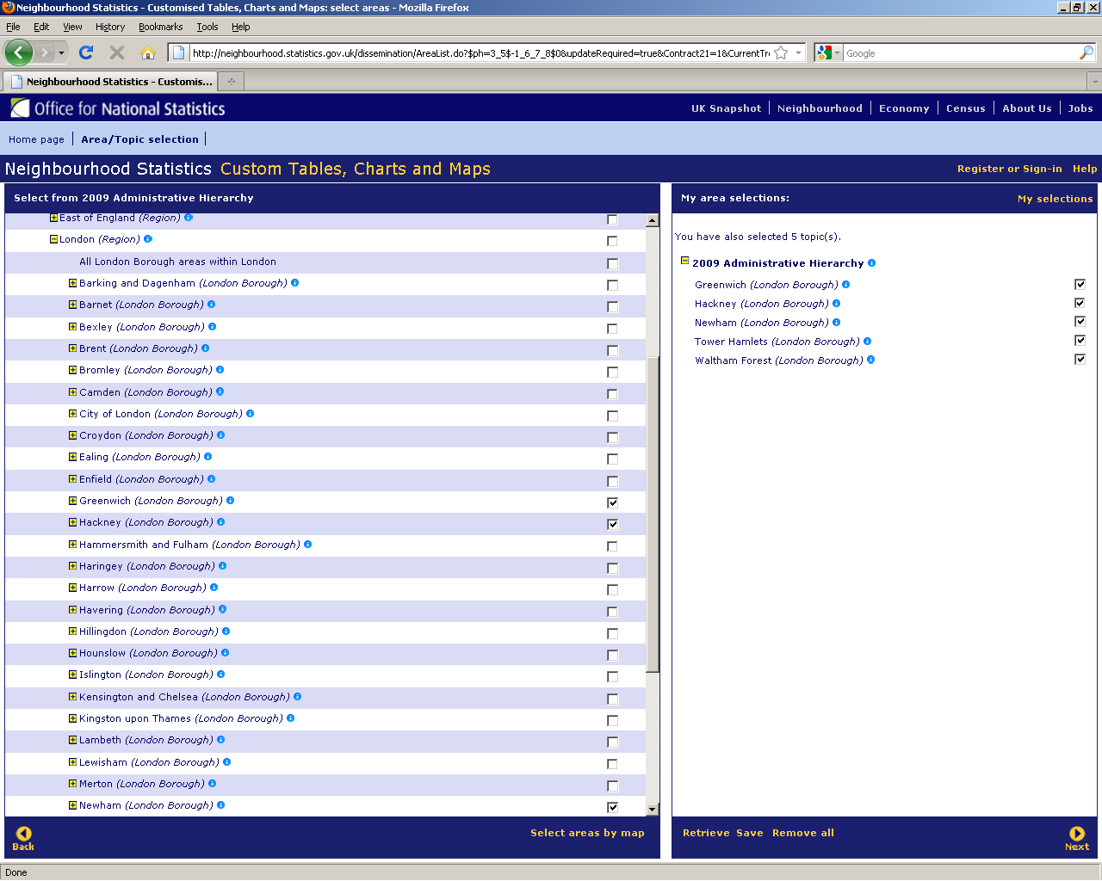
If you’re basing your selections on the 2009 Administrative Hierarchy you can choose whole regions, boroughs, or wards within boroughs (or a mix of all three). Clicking Next will show you the data for the topics you selected for the areas you’re interested in:
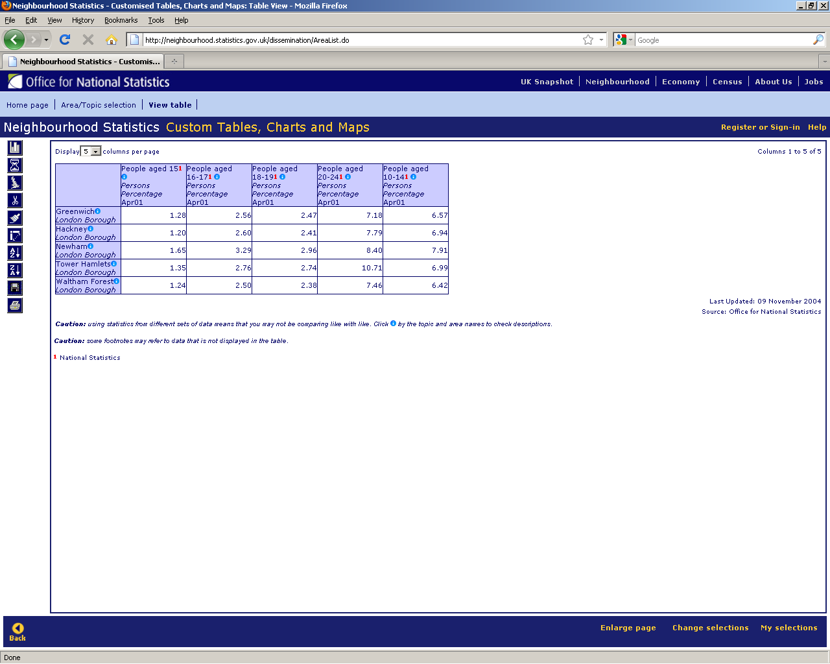
- From here, you can do lots of things to the data by using the icons on the left hand side. You can:
  - Show it as a chart
  - Map it
  - Remove columns
  - Sort the figures
  - Swap the table around, so the rows become columns and vice versa
  - Save the table to your computer

The best way of getting used to Neighbourhood Statistics and getting an idea of what it might be able to do for you is using it, so try playing around and see what happens!

The Taking Part survey
https://www.gov.uk/government/organisations/department-for-culture-media-sport/series/taking part
What is it?
- A continuous national survey of households in England, commissioned by DCMS in partnership with English Heritage, ACE, Sport England and MLA
- In-home interviews provide information on adults’ (and, since 2008/09, 5-15 yr olds’) cultural and sport attendance and participation
- Launched mid-July 2005
- Sample includes adults and children. (2008/09 14,000 adults, 1,000 children
2009/10 6,000 adults, 500 children)
Detailed information available on archives, arts, libraries, museums, galleries, heritage, sport and internet access includes:
- attendance and participation
- frequency and types of engagement
- reasons for attendance / non-attendance
- sex
- age
- household structure
- education
- work status
- income
- housing tenure
- geographic region
- ethnic origin
- religion
- health
- disability
- ownership of a motor vehicle
- socio-economic group
- ACORN type

Pros and cons
- Asks detailed questions about peoples’ engagement with culture and sport – covering attendance and participation
- Includes data from under-16s
- Lots of research on the dataset already available, which may be able to answer your questions
- All data is free.
- You can access a range of types of information Statistical releases e.g. yearly overview reports to ad hoc research reports e.g. trend analysis
- Data only available down to region level – e.g. for London, or the North East – cannot ‘zoom in’ any further
- Smaller sample size in 2009/10 means analysis at a regional level, or on data from under-16s, is subject to larger margins of error.

Area Profile Reports
http://www.theaudienceagency.org/services/apr
What are they?
Area Profile Reports (APRs) contain data on resident populations. You can use these reports to find out more about the people living in your local area including data on demographics and arts attendance. The purpose of these reports is to assist organisations in their marketing planning and strategic development. Data is broken down by postcode sector allowing you to search for areas where target audiences live and understand the make-up of your catchment area in detail.
What can they be used for?
- Understanding organisational performance against potential
- Identifying hot-spots
- Understanding cold-spots
- Targeting to post-code sector level
- Selecting promotional/advertising media

Pros and Cons
- Quick targeted way of reviewing what is known about your local area.
- Reports are free to National Portfolio Organisations (NPOs) who can request 1 per year.
- Data is only available down to a region level – e.g. for London or the North East.
- These cannot be produced in-house. Non NPO’s have to pay £50+VAT per report.
- Area Profile Reports can take a couple of weeks to be produced, so plan in advance

Geo-demographic profiling – Mosaic
http://www.experian.co.uk/business-strategies/mosaic-uk.html
What is it?
- Geo-demographic profiling explores what people are likely to be like, and how they might behave, based on where they live
- Mosaic segments the neighbourhoods of Great Britain into different lifestyle ‘groups’ and ‘types’ according to their postcode
- Segments describe of the typical nature of people living in an area, including financial circumstances, consumer and leisure habits, values and motivations
- It’s important to remember it describes a neighbourhood according to the mix of individuals or households within it – it’s not saying that everyone with a certain postcode will be the same ‘sort’ of person, just that they’re more likely than someone living at a different postcode to have certain attributes.
- The segmentation is derived from lots of different data sources:
  - Census data (includes age, ethnicity, family relationships, work, health, transport, commuting etc)
  - Electoral Roll (more frequent than the census, shows numbers of resident adults and migration patterns)
  - Land Registry (house purchasing and prices)
  - County Court Judgements
  - Creditworthiness
  - Surveys, qualitative research, photographs
- You can use it to:
  - Understand more about the potential audiences in a particular area
    - How are people within a mile of my venue likely to enjoy their free time? Could this be a way in to engaging with them?
  - Highlight where those most likely to use your service might live
    - We’re doing some new and more diverse programming that includes contemporary dance – whereabouts do contemporary dance fans live, and what communication methods do they respond to best?
  - Profile your existing audience to find out more about them
    - Are they representative of my local area?

Below are some examples of the types of information generated by Mosaic Profiling.

These are the characteristics of the Mosaic type Urban Cool, which falls within the Liberal Opinions group:
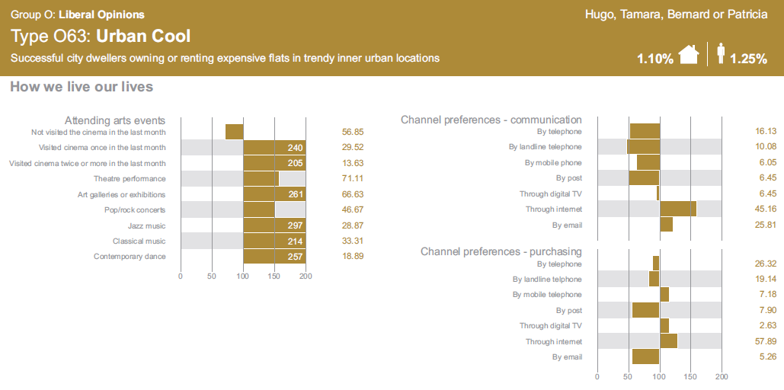

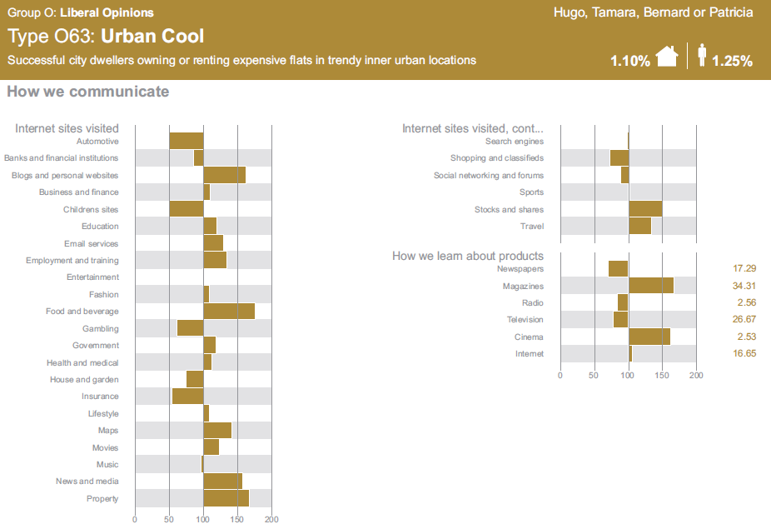

And this is a map, showing the different Mosaic groups assigned to postcodes across an area of Kensington and Chelsea/Westminster:
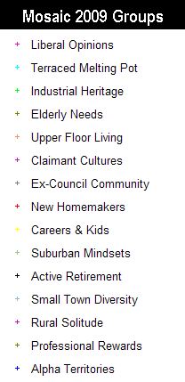
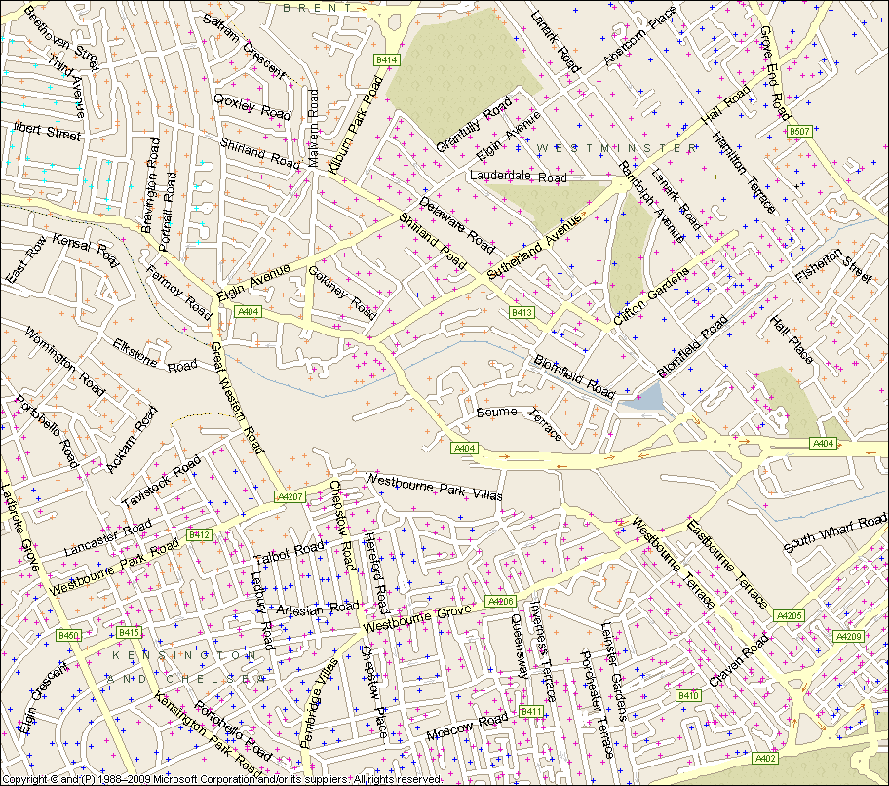
Each mark on the map represents on postcode, covering approximately 15 households. The map shows that the area to the south-west is populated mostly by Alpha Territories households (likely to be very well off, and work in high-powered jobs) and the south-east populated mainly by Liberal Opinions households.
Pros and cons
- Can give you a good indication of the likely qualities of the population of any geographical area, across a massive range of topics – where they holiday, what they read, likely financial status, opinions etc
- Flexible - can be used to describe an area, in terms of the sorts of people living there, or can be used to profile some existing data, for example getting a picture of your current audience by profiling postcodes from your box office or mailing list
- Cost attached to getting detailed data/reports
- Quite a lot of postcodes are needed to build an accurate profile (at least 1,000 for a Mosaic Type profile)

Where can I find the data?
- Broad data available at the Mosaic website (as below)
- You can get the Mosaic Type of an individual postcode and also find out more about each group and type using Experian’s interactive guide, at http://www.experian.co.uk/marketing-information-services/mosaic-uk-2009-interactive-guide.html
You need to register, but it’s free to do so.
- You can get a Mosaic profile, at group level, for free by visiting http://www.experianintact.com/home.aspx. After registering and following the instructions you will be presented with a data audit, part of which is a Mosaic profile.
- The Audience Agency can also support you to benefit from Mosaic Profiling Services in the context of developing audiences for your organisation. There is a cost attached to these services.

The ACE Arts Audiences: Insight segmentation
http://www.artscouncil.org.uk/what-we-do/research-and-data/arts-audiences/arts-based-segmentation-research/
What is it?
- A segmentation of the English population, with a focus on cultural attendance and participation.
- Divides the population into 13 types (segments), depending on their level of engagement with the arts:
  - Two types are highly engaged, attending and participating
  - Seven types have some engagement
    - Four of these types attend and participate
    - Three of these types only participate
  - 4 types are not currently engaged
- The segmentation describes:
  - socio-demographic characteristics
  - arts attendance and participation
  - other cultural engagement (libraries, museums, archives, cinema)
  - participation in sports
  - volunteering
  - ...and other factors which might help plan an engagement strategy or marketing plan with a particular segment
- Profiles are available of areas, showing the proportions of each segment within a geographical area
Pros and cons
- Arts-specific, so can be useful for understanding areas based on the people’s likely engagement with the arts
- Paints a picture of different sorts of arts attenders/participants to make it easier to visualise your potential audience, and what they are likely to be interested in
- Useful for strategic planning and thinking about how to target audiences who are less engaged currently.
- Free reports and supporting materials available to ACE regularly funded organisations
- Only 13 segments compared to Mosaic’s 67, so less targeted
- Quite a lot of postcodes are needed to build an accurate profile (at least 1,000 for a Mosaic Type profile)
Where can I find the data?
- Data available at topline level is available for free on the Arts Council website at http://www.artscouncil.org.uk/advice-and-guidance/browse-advice-and-guidance/arts-audiences-insight-2011
- ACE Arts Audiences: Insight area reports are available. These are reports focused on a geographical area, where data from the research can be compared against your own audience data. These are available as individual reports or as part of an Area Profile Report and there is a cost attached.

- Sector-specific research groups that you can or may already be part of

Public Services Quality Group for Archives and Local Studies (PSQG)
PSQG was set up in 1996 as an informal collaborative network for archivists interested in best practice and quality issues. The PSQG steering group meet regularly at London Metropolitan Archives with sub-committees also meeting to work on specific issues, one of which currently is Volunteering. Membership is open to all and information can be found at http://www.archives.org.uk/si-psqg/public-services-quality-group-psqg.html

CIPFA
CIPFA Social Research offer tools for consultation with users and stakeholders to build the picture of how services are perceived, used and can be improved to better meet customer needs. There are a range of library survey tools and a visitor survey for Archives http://www.cipfasocialresearch.net/archives/

SCONUL
The Society of College, National and University Libraries (SCONUL) is a membership organisation that represents all university libraries in the UK and Ireland, as well as national libraries and many of the UK’s colleges of higher education. You can access research that has been carried out by the organisation on their website at http://www.sconul.ac.uk/publications.

LibQUAL+®
LibQUAL+® is a suite of services that libraries use to solicit, track, understand, and act upon users' opinions of service quality. Provided by the Association of Research Libraries (ARL). the program's main component is a Web-based survey bundled with training that helps libraries assess and improve library services, change organizational culture, and market the library. More than 1,000 libraries have participated in LibQUAL+®. http://www.libqual.org

The National Student Survey
Administered by Ipsos MORI,this is an annual survey that has been conducted since 2005. The survey runs across all publicly funded Higher Education Institutions (HEIs) in England, Wales, Northern Ireland, and Scotland. Additionally, Further Education Colleges (FECs) in England and Further Education Institutions (FEIs) in Wales with directly funded Higher Education students are eligible to participate. The survey asks final year undergraduates to provide feedback on their courses. One of the 7 sections in the survey is about Learning Resources. http://www.thestudentsurvey.com
- Thinking about your own systems for Understanding your Audiences

As this resource has shown there are many existing or ‘secondary’ sources of information out there that you can tap into to help you understand your audiences better. And there are many types of new or ‘primary’ research that you can initiate yourself to do this too. The most important thing to do to ensure you spend your time most fruitfully is to establish first what it is that you really want to be able to do. Then you can identify how you can get this information, seeking advice where you need to. This table below provides an example of how you can approach this process and common areas of understanding that organisations need in relation to their audiences.
What is it I want to be able to do? | How might I get this type of information? | What will help me?
Understand who my current audiences are | - Using my own data about audiences to create mapping and geo-demographic profiling, examining booking and attendance patterns.  - Using existing data about levels of engagement and participation both within my organisation and more widely across the sector. | - Primary data held within my organisation.  - The Taking Part Survey about national levels of cultural attendance and participation.
Investigate what the experience is of my current audiences | - By conducting primary research with event attenders. | - Current mailing lists we have could be used to contact people to ask to take part in research.  - Staff and volunteers during events briefed to ask questions.
What is it I want to be able to do? | How might I get this type of information? | What will help me?
Understand where potential new audiences may come from | - By defining a geographical area around my venue and understanding the demographic and other characteristics of that area, as well as gaining insight about levels of current engagement in the arts | - APR reporting including an Arts Audiences Insight Segementation of my area.
Investigate potential new audiences | - Exploring the distribution and concentration of particular groups of interest,  - Understanding general audience trends as a context for development | - Office for National Statistics.  - Local research into contacts and communities of interest.  - Case studies of existing good practice on The National Archives website and Culture Hive.

Setting up systems for your own audience research
There are many options available if you want to conduct your own research with your audiences to get to know more about them and what they think of the work you are doing.

The most important things to think about first are,

- What do you need to know and what would be nice to know?
- How much time are you asking your audience to give and is it proportionate to the experience you are giving them.
For example if they are visiting a free exhibition you would not expect to conduct a 20 minute interview with them, it would be more proportionate to do a 1-2 minute vox-pop interview.
- How will you present the information you collect afterward and who will be interested in it?

Our experience has taught us that most people collect too much information and do not use it to it’s full potential. We encourage people to keep things simple. Below is an example from a community film festival in Tottenham that was managed by Film London in partnership with the London Borough of Haringey in 2012.

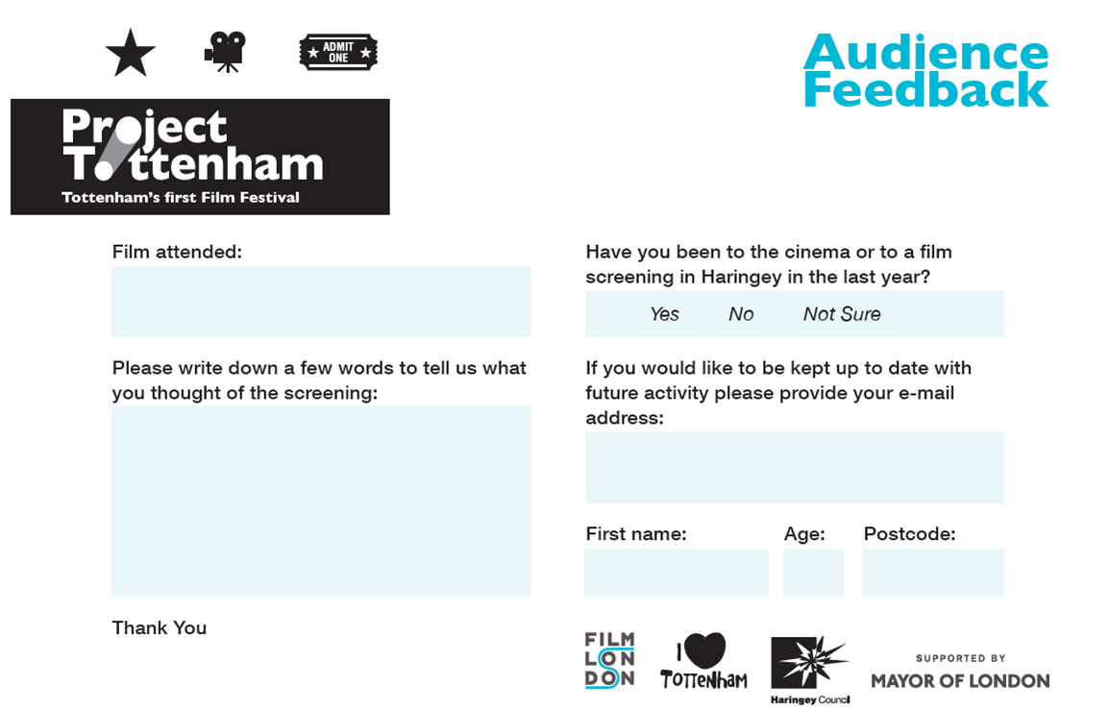

This card took 1-2 minutes to fill in and resulted in the project being able to prove that,
- The project had attracted an intergenerational audience, with audience members ranging from 7-75 years old.
- The project that attracted new audiences to Tottenham to watch film; 71% (123 people) of the 170 people that filled in a feedback card told us they had not watched a film in the cinema or at a screening in the borough in the last 12 months.
- The project had attracted local residents.
- The project had brought new audiences into the borough with people coming from 20 other London boroughs as well as other areas of the UK.
- The project demonstrated an appetite for screening films in community settings in Haringey, with a range of audience feedback comments requesting more regular activity of this kind in the borough.

