**Reviewing and Engaging Your Stakeholders**

***“Seek first to understand, then to be understood”*** (Dr Stephen Covey)

**Introduction**

Resilient heritage organisations develop a clear understanding of their stakeholders and engage with them effectively to....

* inform service development and improvement
* create supporters of and advocates for the service.

Stakeholder engagement is also a key part of all types of service review.

This section provides practical tools to help you identify your stakeholders, establish their needs and plan how to understand, engage with and influence them more effectively.

When working on stakeholder review and engagement, remember the following principles:

* **“Seek first to understand, then to be understood”**
* **Think ‘win/win’**
* **You can’t force people to change, either overtly or covertly!**
* **Successful influencing is a collaboration….allow your ideas and views to be built on by others so that you create a consensus which is more powerful than what you started with**

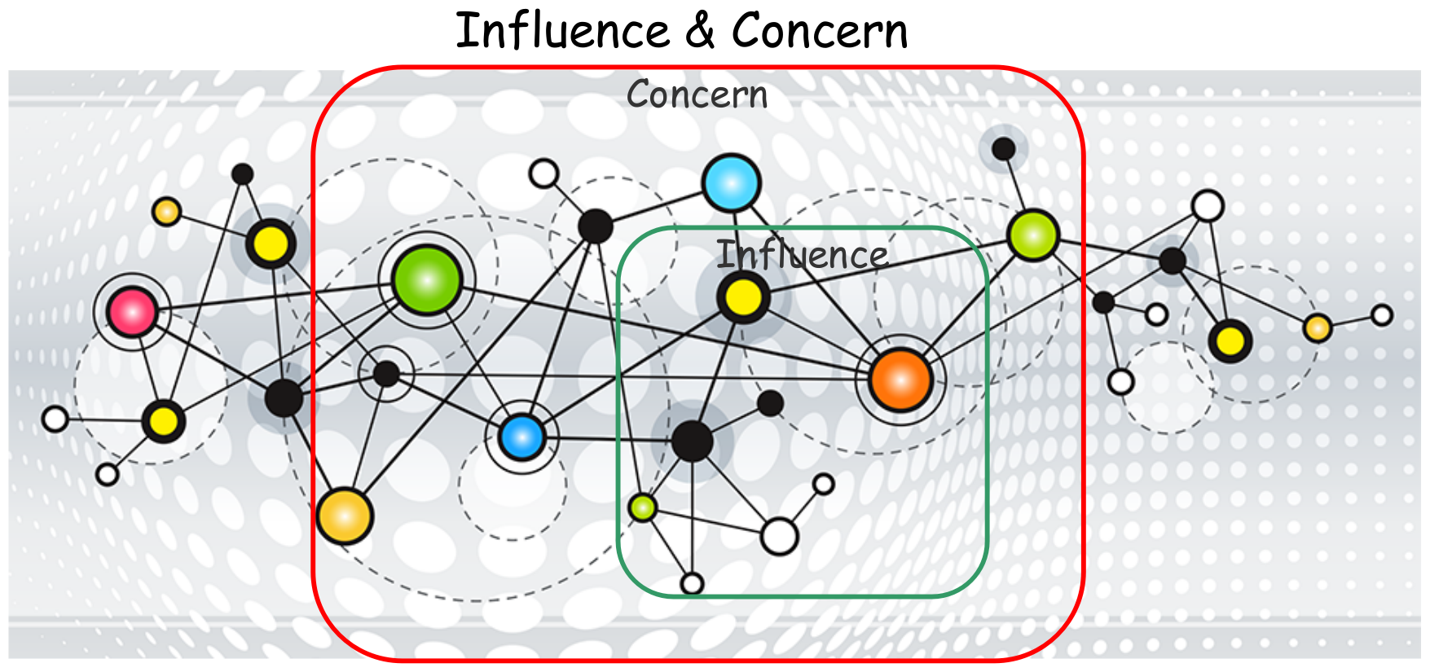Also, remember that you can’t influence everyone! One of the keys to personal and organisational resilience is to focus your energies, resources and passion on what is within your ‘sphere of influence’….and to forget about what is not! Sounds harsh…but this skill really makes a difference! Your ‘sphere of influence’ is always smaller than your ‘sphere of concern’. However, the more you collaborate the more your ‘sphere of influence’ grows.

**Understanding your stakeholders**

***What are their needs, their likes and preferences? How do they like to be communicated with?***

**Users?**

**Parent body?**

**External partners?**

**Internal partners?**

**Workforce?**

**Wider community?**

**Creating advocates for the service**

This would all be so much easier if you had unlimited time! But you haven’t, so you need to target your energies carefully. This technique will enable you to identify whom you need to be influencing. Often, creating advocates for your service is not as straight forward as it sounds…..you might need to influence someone, to influence someone else! Remember that it doesn’t matter if the change ends up being “someone else’s idea”!

Conduct this exercise with your collaborators and review it at regular intervals or when the internal environment changes. A small amount of time spent on this will pay great dividends later.

**‘Micro-Political Analysis’**

1. Consider the ‘system’ that you are seeking to influence (i.e. the network of people)
2. Write the names or roles of all the key people and groups within the ‘system’. Attach these to a large sheet of paper.
3. Draw links and the prime flow of information/data between the different people / groups.
4. Increase the relative strength of the link where there are strong alliances between individuals
5. Where there are conflicts, mark the lines with a double cross through.

The example below provides an analysis of a small ‘system’. “Peter” is the central role (He is Office Manager). The various other players have different levels of relationship with Peter; e.g. Peter has strong relationships with Gavin and John. Also shown are the different exchanges of information, etc. There is one relationship with real issues – Peter and George.



When you have completed this ask various staff within the ‘system’ about their views on the analysis:

* **Have you included all the significant players?**
* **Are the links and their relative strength and conflicts correct?**
* **What are people’s perceptions on why these relationships are strong or in conflict?**

**Support or Resist Matrix**

Consider the orientation of each person to the service:

* Support/Resist – is the person supportive of or resistant to the potential changes?
* Power / influence – does the person have high or low power / influence in this situation?

Write the names of the people in the appropriate position on the following worksheet:

SUPPORT/RESIST

Highly Resistant Neutral Highly supportive

|  |  |  |
| --- | --- | --- |
| Strong  P  O  W  E  R |  |  |
| Weak |  |  |

Think about who falls into which category:

|  |  |
| --- | --- |
| **Influential and supportive** | **Influential and resistant** |
| **Not influential and supportive** | **Not influential and resistant** |

**So whom do we need to influence / collaborate with in the future?**

**What is their usual leadership / communication style?**

**What are their potential ‘interests’ in supporting the identified activity (e.g. position, career, territory, advantages, ideological interests, personal values, sense of personal and professional identity, etc.)?**

**Your Stakeholder Engagement Plan**

|  |  |  |
| --- | --- | --- |
| **Person / group** | **How will we communicate with / engage them?** | **When can we do this?** |
|  |  |  |