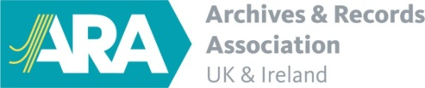
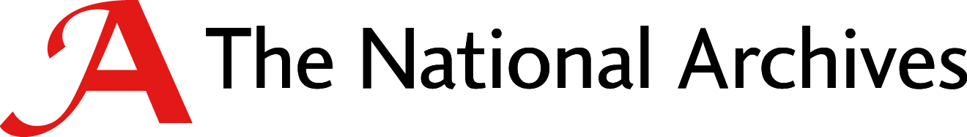
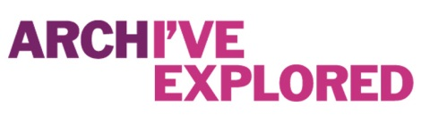

#explorearchives week evaluation
Did you sign up to the thunderclap?
Number of Facebook page likes before #explorearchives week
Number of Twitter followers before #explorearchives week
Which hashtags did you use
Number of posts on Facebook
Total reach of Facebook posts (broken down to fans and non-fans)
Average reach of Facebook posts
Best post on Facebook (include content and stats)
Engagement % for posts
Number of posts on Twitter
Total impressions on Twitter
Average impressions on Twitter
Best post on Twitter (include content and stats
Engagement % for posts
Number of Facebook page likes at end of campaign
Number of Twitter followers at end of campaign

Any feedback on the daily hashtags or the thunderclap?

