Collaborative Doctoral Partnerships (CDP) 2022-23
Expression of interest form |  | 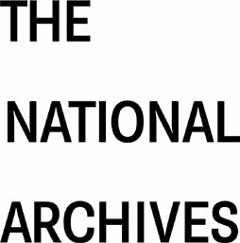
Full guidance
Guidance on applying for the Collaborative Doctoral Partnership (CDP) scheme can be found at our website.
Initial enquiries
We ask that all those interested in co-supervising a CDP PhD inform our Research and Academic Engagement team in the first instance. The deadline for these initial enquiries is 17:00 on Friday 27 August 2021.
Expression of interest
If you receive a positive response to your initial enquiry, please complete this form in collaboration with your proposed first co-supervisor at The National Archives.
Deadline
Please submit this form to research@nationalarchives.gov.uk by 17:00 on Friday 17 September 2021.

1. Details of potential co-supervisors at the Higher Education Institution (HEI)
First HEI co-supervisor name:
Job title and department:
Name of HEI:
Email address:
Second HEI co-supervisor name (must be based at same HEI):
Job title and department:
Email address:
2. Details of potential supervisors at The National Archives
First co-supervisor name:
Job title and department:
Second co-supervisor name:
Job title and department:
3. Title of proposed CDP project
4. Please state the research area(s) that this CDP would cover, based on the AHRC’s list of its Primary Research Areas (Levels 1 and 2).

5. Please summarise the proposed research (300 words max.) making reference to:
- Importance, originality and innovativeness of the topic
- Relevant collections or expertise at The National Archives
- Feasibility as a PhD
6. Please summarise how the proposed research would benefit The National Archives and its audiences (300 words max.). You could consider the following:
- Our business plan, Archives for Everyone, 2019-23
- Our research strategies
- Existing or future work at The National Archives

7. Please summarise how the proposed research might progress if restrictions relating to Covid-19 are in place. (max. 200 words). You could consider the following:
- Access to primary and secondary material
- Student support
- Collaboration between The National Archives and the HEI

